Unit 11

Advanced Analysis

- Introduction

In this unit consideration is given to some of most widely used the advanced statistical methods such as factor analysis, logistic regression and path analysis. Factor analysis is widely used in business research to reflect hidden or latent variables which can not be directly measured but tend to be indirectly measured by other measures such as a bank of questions. Examples are intelligence quota, ambition, commitment and technical prowess.

Logistic regression is used when the outcome variable is binary or dichotomous, for example, success or failure, good credit risk or bad credit risk. This technique has become very widely used in business decision-making, especially in the financial sector. On the other hand, path analysis is used to examine the causal effects (direct or indirect) to an ultimate variable. This technique provides additional benefits of graphical chain linkages between variables. It is often used to compare net effects of one situation with the net effects of others. Supposing two factories are producing same product and you would like to study which factors are responsible for better quality of products. Then path analysis will be able to illustrate a comparative analysis as the path coefficients are the standardised regression coefficients.

Due to the complex nature of these techniques to use them one has to use a specialist computer package such as SPSS, EXCEL just does not have the functionality to cope. SPSS will be used to outline these techniques and the data sets used in the examples can be downloaded from the module web page.

This unit is only vital for those who will be doing more advance analysis, probably based on survey data and as such may be left unread by many.

A good book for this unit is “Applied Multivariate Techniques” by S Sharma, published by John Wiley & Sons, Chichester, 1996.

13.2 Factor Analysis

In SPSS, under data reduction one can employ Factor Analysis to reduce a data set to fewer variables. The way this is done is to form new variables by finding a linear combination of variables which are highly correlated. These new variables are created in a way to be orthogonal or uncorrelated. This means that as well as making the data more manageable by reducing the number of variable – it is also a means to overcoming the problems of multicolinearity. This procedure can also be used to create variables for phenomena that are not directly measurable such as intelligence quota, love or empathy.

The method was discovered by Charles Spearman in 1904 when examining a correlation matrix of boys test scores:

 | Classics | French | English | Mathematics | Discrimination of Pitch | Music
Classics | 1.00 | 0.83 | 0.78 | 0.70 | 0.66 | 0.63
French | 0.83 | 1.00 | 0.67 | 0.67 | 0.65 | 0.57
English | 0.78 | 0.67 | 1.00 | 0.64 | 0.54 | 0.51
Mathematics | 0.70 | 0.67 | 0.64 | 1.00 | 0.45 | 0.51
Discrimination of Pitch | 0.66 | 0.65 | 0.54 | 0.45 | 1.00 | 0.40
Music | 0.63 | 0.57 | 0.51 | 0.51 | 0.40 | 1.00

This suggested that the scores are related to some hidden factor i.e.:
X_{i} = a_{i}F + e_{i}

Where X_{i} is a standardized score, a_{i} is the factor loading and its square is the proportion of the variance accounted for by the factor. From this Spearman developed a two factor theory of mental tests: one common to all tests, general intelligence, and one specific to that test. This was later modified to allow a test result to consist of several common factors plus a part specific to the test.

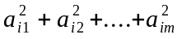 are the communality of X_{i} the part of its variance which is related to the common factors. Var(e_{i}) is called the specificity of X_{i}., (this is the part which is unrelated to the common factors).

So Music = 0.8F + A_{m} and English could be 0.6F + A_{e}

The idea is to represent complex data by new variables formed by linear combinations of the data.

These are called FACTORS and one selects as many factors as needed to explain the variation in the data. One gets an idea from examining the eigen values. Often eigen values greater than one are considered, the rest considered to be making a negligible contribution. To explain eigen values is beyond the scope of this unit, those who are interested should consult Sharma, (1996).

Stages for Factor Analysis

- Construct the correlation matrix. Remove variables which are uncorrelated with others - they will not have a common factor.
- Extract the factors - choose the required number of factors
- Rotate or transform the factors to make them more understandable
- Compute the scores for the factors.

The usual method for rotation is VARIMAX rotation. The idea here is that the interpretability of a factor can be measured by the variance of the square of its factor loadings

Tests of adequacy of the approach

1. Bartlett’s test. This is used to determine is values in the correlation matrix are different from an identity matrix. We want large significant values.

- Kaiser-Meyer-Olkin measure of sample adequacy - compares magnitudes of observed correlation coefficients to partial correlation coefficients. We want this to be large

Kaiser gives values of KMO>0.9 marvellous
0.8<KMO<0.9 meritorious
0.7<KMO<0.8 middling
0.6<KMO<0.7 mediocre
0.5<KMO<0.6 miserable
KMO< 0.5 unacceptable

Example:
Consider customers' view about soft drinks as elicited from a questionnaire which is contained in the file sopftd.sav.

List of Statements For Soft Drink Data
----------------------------------------------------------------------------
1. Brand X has a refreshing taste.
2. I prefer Brand X because it has fewer calories than other drinks.
3. Brand X quenches my thirst immediately.
4. I like the sweet taste of Brand X.
5. I prefer drinking Brand X after workouts and sports because it gives me
energy.
6. I prefer Brand X because it comes in environment friendly packaging.
7. Brand X has minerals and vitamins that help quench my deep down body thirst.
8. Brand X has a unique flavour of its own.
9. Brand X has the right mix of minerals and vitamins that are healthy for my
body.
10. I prefer to drink Brand X when I am really thirsty.
----------------------------------------------------------------------------
The correlation Matrix between the questions is:

X1 X2 X3 X4 X5 X6 X7 X8 X9 X10
X1 1.00000
X2 .13042 1.00000
X3 -.30347 .45397 1.00000
X4 .82469 .04973 -.24185 1.00000
X5 .15959 .92821 .50054 .11268 1.00000
X6 .00228 -.11096 -.11062 .08947 -.15866 1.00000
X7 -.37603 .40868 .90525 -.29321 .42707 -.09604 1.00000
X8 .85403 .05624 -.33650 .89262 .09162 .09030 -.41180 1.000
X9 .12162 .93191 .51023 .07539 .93828 -.13515 .44760 .05852 1.000
X10 -.31893 .44474 .86820 -.27956 .45792 -.08606 .90377 -.37104 .48886 1.000

To activate factor analysis in SPSS – go to Analyze, then Data Reduction and Factor. The KMO and Bartlett tests are available under descriptive and one often wishes to save the factor scores which are the new variables.

Kaiser-Meyer-Olkin Measure of Sampling Adequacy = 0.81358

Bartlett Test of Sphericity = 1054.0528, Significance = 0.00000

Thus the approach is sensible.

Extraction 1 for analysis 1, Principal Components Analysis (PC)

Initial Statistics: - this output can be ignored - until that is one gets to the final statistics

Variable Communality * Factor Eigenvalue Pct of Var Cum Pct
*

X1 1.00000 * 1 4.40008 44.0 44.0
X2 1.00000 * 2 3.03714 30.4 74.4
X3 1.00000 * 3 1.04960 10.5 84.9
X4 1.00000 * 4 .90893 9.1 94.0
X5 1.00000 * 5 .17676 1.8 95.7
X6 1.00000 * 6 .12843 1.3 97.0
X7 1.00000 * 7 .10230 1.0 98.0
X8 1.00000 * 8 .08124 .8 98.8
X9 1.00000 * 9 .05912 .6 99.4
X10 1.00000 * 10 .05640 .6 100.0
PC extracted 3 factors.

Factor Matrix:
Factor 1 Factor 2 Factor 3

X1 -.36741 .84115 .09365
X2 .71964 .55196 -.22007
X3 .87913 -.06169 .29283
X4 -.36714 .81019 .27975
X5 .72720 .58648 -.20471
X6 -.18407 -.02462 .72058
X7 .87307 -.15394 .31673
X8 -.43722 .82381 .19061
X9 .74885 .55461 -.18985
X10 .87331 -.10104 .30749

Final Statistics:

Variable Communality * Factor Eigenvalue Pct of Var Cum Pct
*
X1 .85129 * 1 4.40008 44.0 44.0
X2 .87097 * 2 3.03714 30.4 74.4
X3 .86242 * 3 1.04960 10.5 84.9
X4 .86947 *
X5 .91470 *
X6 .55372 *
X7 .88626 *
X8 .90616 *
X9 .90441 *
X10 .86743 *

So three factors are required and these explain 84.9% of the original variation in the data.

Skipping rotation 1 for extraction 1 in analysis 1

Factor Score Coefficient Matrix:
Factor 1 Factor 2 Factor 3

X1 -.08350 .27695 .08922
X2 .16355 .18174 -.20967
X3 .19980 -.02031 .27899
X4 -.08344 .26676 .26653
X5 .16527 .19310 -.19504
X6 -.04183 -.00811 .68653
X7 .19842 -.05069 .30176
X8 -.09937 .27125 .18160
X9 .17019 .18261 -.18088

X10 .19848 -.03327 .29296

1. Brand X has a refreshing taste.
2. I prefer Brand X because it has fewer calories than other drinks.
3. Brand X quenches my thirst immediately.
4. I like the sweet taste of Brand X.
5. I prefer drinking Brand X after workouts and sports because it gives me
energy.
6. I prefer Brand X because it comes in environment friendly packaging.
7. Brand X has minerals and vitamins that help quench my deep down body thirst.
8. Brand X has a unique flavour of its own.
9. Brand X has the right mix of minerals and vitamins that are healthy for my
body.
10. I prefer to drink Brand X when I am really thirsty.

Rotated solution

Factor Score Coefficient Matrix:
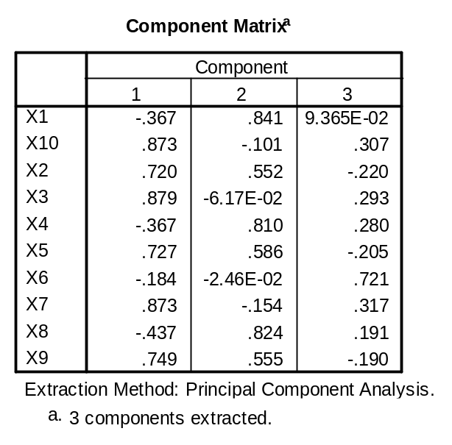
We identify those variables with high, positive values for each factor. For example, factor 1 has high values relating to variables 3, 7 and 10 and all relate to quenching thirst. These factors can be saved as variables and given appropriate names. So factor 1 can be named Quench, factor 2 can be named Taste and factor 3 named Environment.

Residuals are again used to determine if the method is reliable - but it is the residual correlation matrix that is examined and low values are hoped for. This is found by subtracting the observed correlation matrix from a predicted correlation matrix. (This is obtained by going to descriptives and then reproduced in the correlation matrix box).

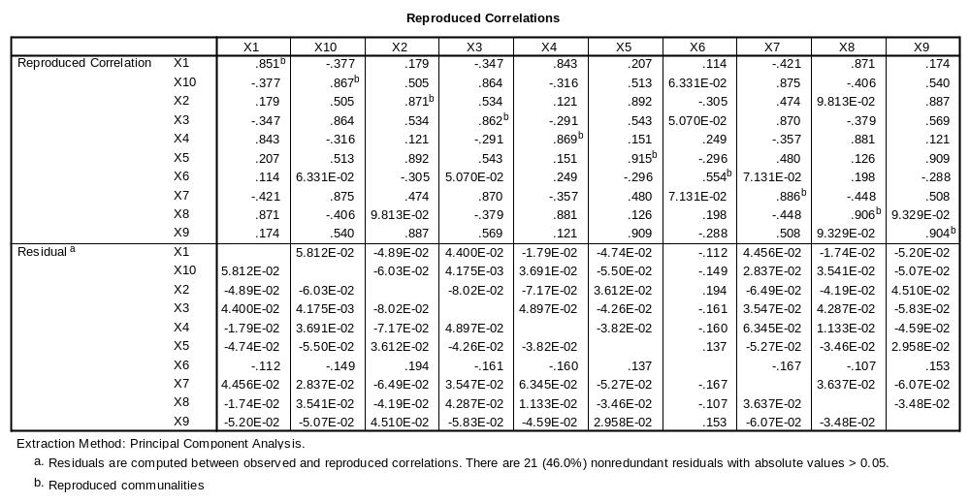
So this looks good. Thus ten variables have been reduced to three variables with an information loss of only 15.1%.

Consider trying to determine what affects the mpg of cars.
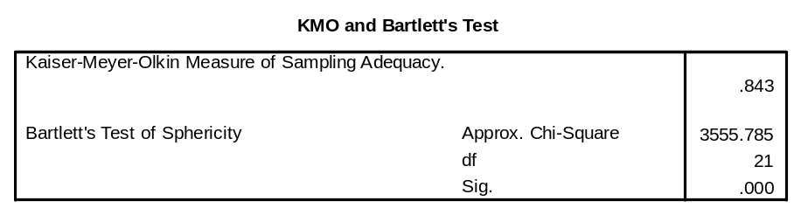
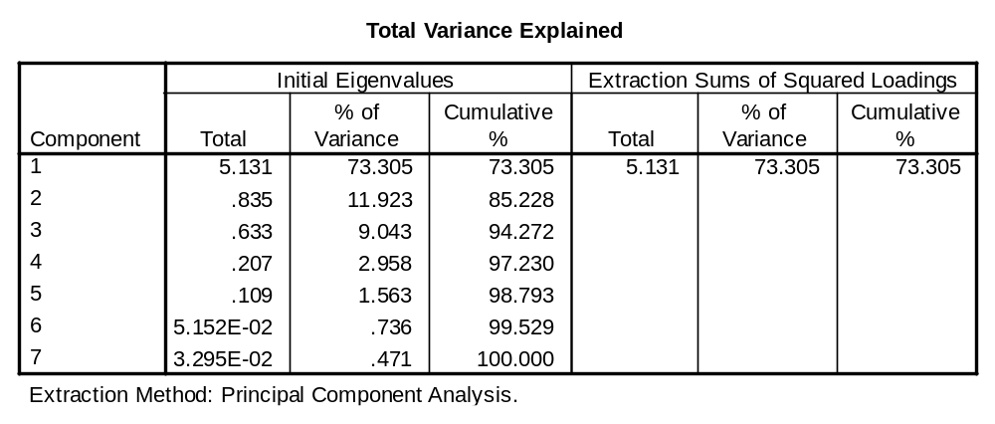
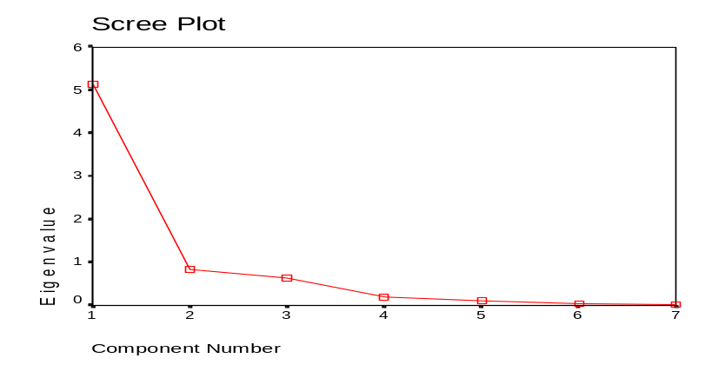
So only one factor is required.

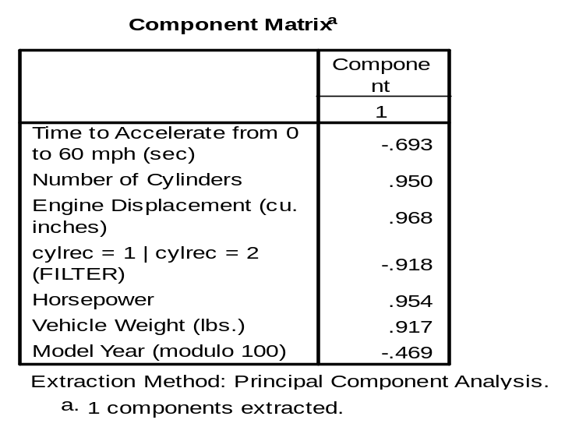
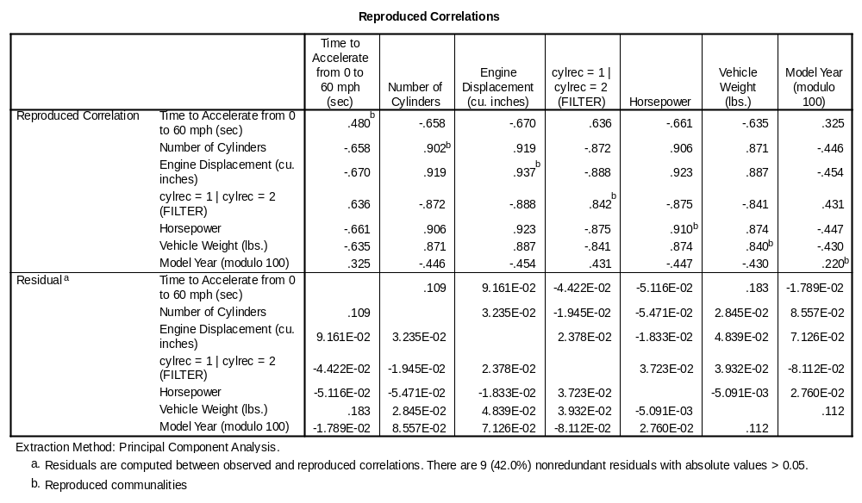

This variable can be used in the regression.

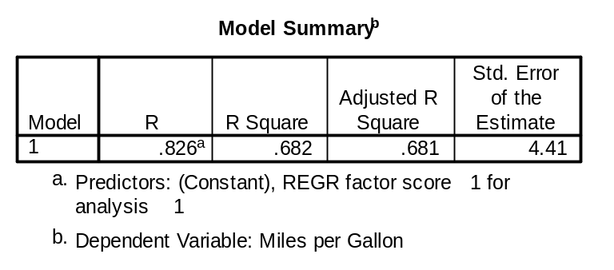
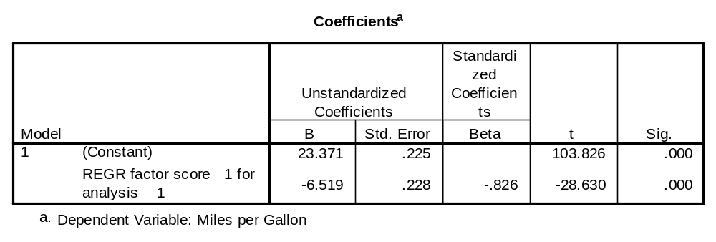
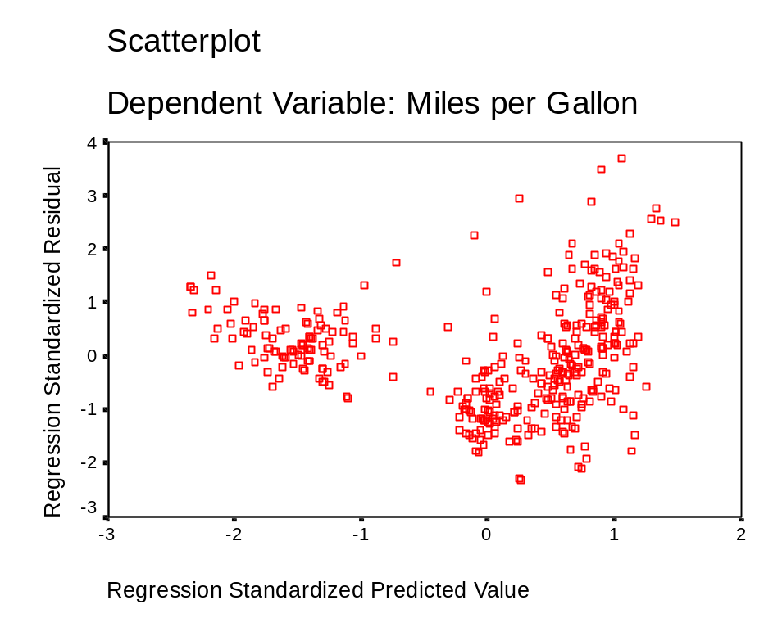

So we are adding a quadratic term.

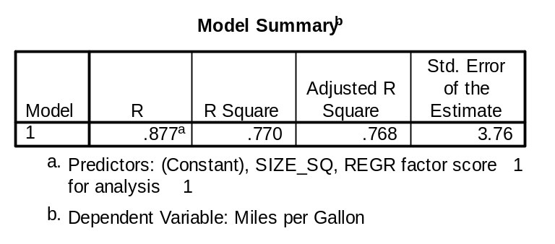

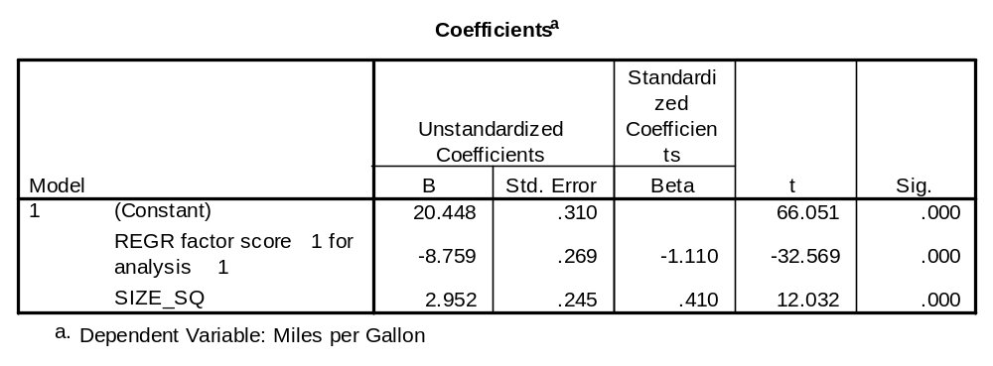

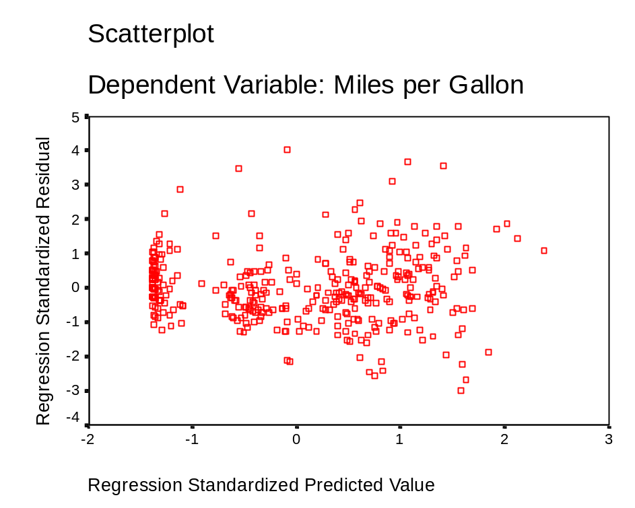

13.3 Logistic Regression

The following should be read in conjunction with the logit regression unit in Sharma, (1996).

Ordinary multiple regression is used to examine influences on a continuous variable. Logistic regression is used when the outcome is a proportion. It is widely used in social, financial, marketing and medical statistics for such applications as credit-scoring and predicting disease severity and progression to inform health care management.

If we used ordinary regression for proportions, we would be likely to hit trouble, because we might be predicting proportions less than zero or greater than 1. To get over this we do not predict the proportion itself, but the logarithm of the odds of the proportion. If the proportion is p then the logit function of p is just log (p / (1-p)). As p goes from 0 to 1 the logit function goes between minus infinity and positive infinity. The logit corresponding to a proportion of 0.5 is zero. The shape of the logit function has a sigmoid shape as shown here.
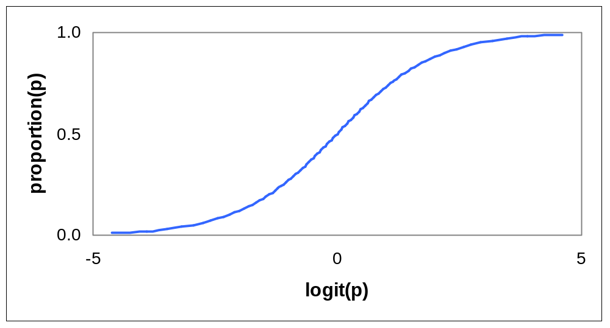

The inverse of the logit transformation (L) is used to calculate back to a proportion from L. It is exp(L)/(1+exp(L)). To calculate a logit (L) from p, or a proportion from L, on a calculator,:-

L from p
- From the proportion (p) calculate p/(1-p)
- Use the ln key to get the Napier or natural log of this

p from L
- Calculate the exponential of L, usually exp. or e^{x}
- exp(L)/(1+exp(L)) gives you p

p | 0.01 |  | 0.3 | 0.5 |  | 0.7 | 0.9 |  | 0.999
logit(p) | -4.60 | -2.20 |  | 0.0 | 0.41 | 0.85 |  | 3.48

Complete this table, and check your results against the graph.

Logistic regression is very similar to ordinary regression, but the Y variable is logit(p) instead of p itself. We can interpret the coefficients in a logistic regression as an increase in the log-odds of the dependent variable, for each unit of the x variable. When the coefficients are not too large, the increase in the log-odds can be interpreted as the proportional increase per unit of x.

The coefficients and P-values have the same interpretation in logistic regression as in ordinary regression. To obtain logistic regression in SPSS follow the path is Analyze>Regression>Binary Logistic.
The analysis below uses some data on first year students at Napier, and on the factors that influence whether they pass their end of year exams at the first try. (The data is in the file Napier.sav).

In ordinary regression

- start with scatter plots of all your possible x variables

In logistic regression

- start with tables of your y variable with each of your x variables, grouping the x’s if necessary. Be sure to calculate the %s for your dependent variable.

When all variables are included together in a logistic regression, the factors are adjusted for each other.

Doing lots of complicated tables would be an alternative to logistic regression. But the regression approach helps to organise things, and also allows you to get a score for the most important factors.

Example: Predicting student performance at Napier University.

Data consists of all first year students entering the first year of the modular course in 1994/5, with Highers as their qualifications at entry, and complete data on age and gender. The variable outcome describes what happened to them at the end of the year. It is coded as shown here.
 | Value Label | Frequency | Percent | Valid percent | Cumulative percent
wthdr sem1 | 1 | 88 | 6.5 | 6.5 | 6.5
wthdr sem2 | 2 | 35 | 2.6 | 2.6 | 9.0
fail | 3 | 254 | 18.6 | 18.6 | 27.6
pass resit | 4 | 155 | 11.4 | 11.4 | 39.0
pass 1st time | 5 | 832 | 61.0 | 61.0 | 100.0
Total |  | 1364 | 100 | 100

The objective of the analysis is to get a score to predict progression. So we decide that we will consider values 4 and 5 as constituting progression, and recode them to get a new variable called progress, with value 1 if progressing and 0 otherwise.

The variables we have that could predict outcome are:-

gender, numbers of higher passes, and age of student.

Taking gender first we can look at the table:-

 | Progress
 | 0.00 |  | 1.00
Gender | Count | Row % | Count | Row %
Male | 267 | 34.0% | 519 | 66.0%
Female | 110 | 190% | 468 | 81.0%
Total | 377 | 27.6% | 987 | 72.4%

We can see that there is a substantial difference between the pass rates for the two genders. (This difference can be tested formally with a Chi-square test which will be explained later in the unit.)

Now we can set this up as a prediction equation with logistic regression. Gender is coded as 1 for male and 2 for female. To make things easier, we will calculate a new dummy variable called gendum with the value of 0 for male, and 1 for female. We will then fit a logistic regression with this as the explanatory variable. The results are:

Dependent Variable. PROGRESS

Chi-Square df Significance

Model Chi-Square 38.210 1 .0000
Improvement 38.210 1 .0000

Classification Table for PROGRESS

 | Predicted Progress
Observed  Progress | No | Yes | Per cent Correct
No | 0 | 377 | 0%
Yes | 0 | 987 | 100%
 | Overall correct |  | 72.36%

Variables in the Equation
Variable | B | S.E. | Wald | df | Sig | R | Exp(B)
GENDUM | .7833 | .1300 | 36.3053 | 1 | .0000 | .1461 | 2.1887
Constant | .6647 | .0753 | 77.8841 | 1 | .0000

Calculating predicted values

The dummy variable for gender takes the value 0 for male and 1 for female, so the prediction equation for logit(pass rate) is:
 | prediction equation | predicted logit | Predicted proportion
males | constant + 0 x gendum
females | constant + 1 x gendum

Complete the values in this table, and compare them with the percentages in the table of pass rates by gender above. This may seem a long, roundabout way for doing something simple. The pay-off comes when we look at several factors together (below).

Multivariate logistic regression

We might now ask whether the greater success of female students might be attributed to their coming in with better qualifications, or because they had different ages at entry. We will now fit a logistic regression with all 3 dependent variables.

(IMPORTANT NOTE: If you were doing this on a real example you would take time to look at the individual explanatory variables by themselves first)
Variables in the Equation:
Variable | B | S.E. | Wald | df | Sig | R | Exp(B)
GENDUM | 0.7655 | 0.1308 | 34.2675 | 1 | 0.0000 | 0.1416 | 2.1501
AGE | 0.0394 | 0.0159 | 6.1579 | 1 | 0.0131 | 0.0508 | 1.0402
NHPASSES | 0.1631 | 0.0509 | 10.2607 | 1 | 0.0014 | 0.0717 | 0.1771
Constant | -0.7415 | 0.4164 | 3.1701 | 1 | 0.0750

Here is the new prediction equation. We can see that all the variables are important. What is more, the effect of gender is somewhat stronger after adjusting for the other variables.

Which bits of output tell you this ___________________________________________

Interpretation of the coefficients for other variables:-
GENDUM :____________________________________
AGE :_____________________________________
NHPASSES :_____________________________________

Now calculate the predicted probability of progression for:-
- A 17 year old male student with 1 pass in highers
- A 20 year old female student with 4 higher passes
- Yourself when you started on this MSc. (if you had highers at entry).

Assessing the Quality of the Models

R-squared is not available for logistic regression, however, guidance is available from the proportion correctly classified. The overall quality of the model is assessed by the scaled Deviance (D):

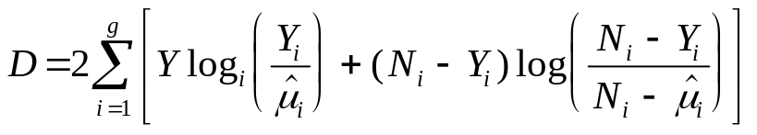

This has a Chi-squared distribution with n-p degrees of freedom. This measure is particularly useful for comparing models in that models are deemed to be significantly different if D₁-D₂ is greater than the Chi squared distribution with q degrees of freedom. This is used in model building and a useful equivalence to forward selection is forward log ratio (LR). One must also think about the logic of the coefficients and their significance.

Example :

In the 1991 U.S. General Social Survey (load 1991 U.S. General Social Survey.Sav) respondents were asked if they were very happy, pretty happy or unhappy and their sex, race and region of residence were recorded.

Tables can be produced to indicate how happiness varies with the variables of gender, race and region. The effect of gender on happiness is examined first.

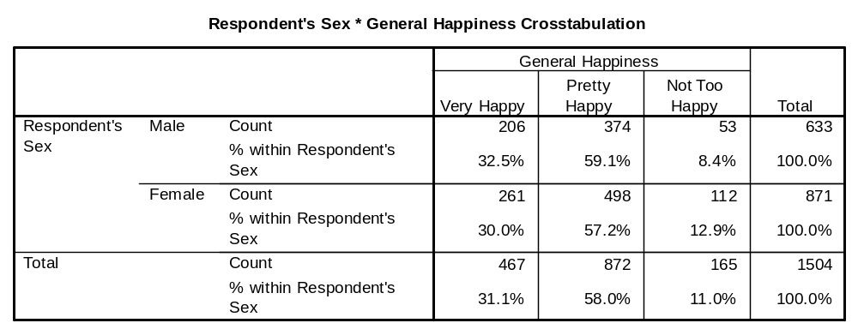

To test formally if there is an association between happiness and gender one can analyse the contingency table by performing a Chi - square test.

H_{o}: there is no association.
v
H_{a} : there is an association.

The test is:

if 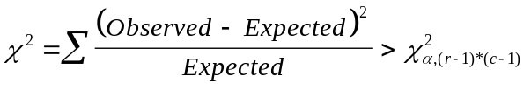then reject H_{o}.

The expected frequency is computed from (row total * column total)/grand total.

This is analogous to the correlation coefficient.

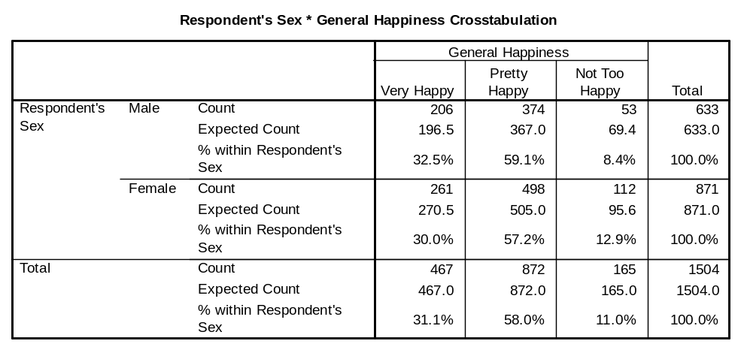

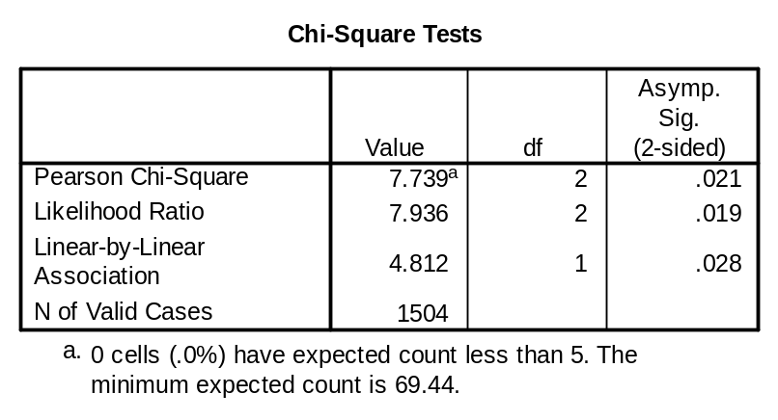

So one may conclude that there is an association.

Consider now happiness and race:
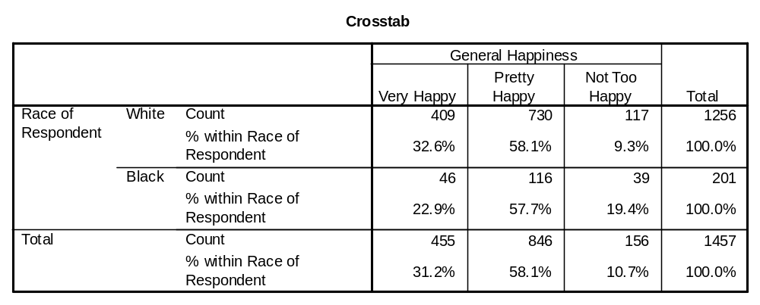
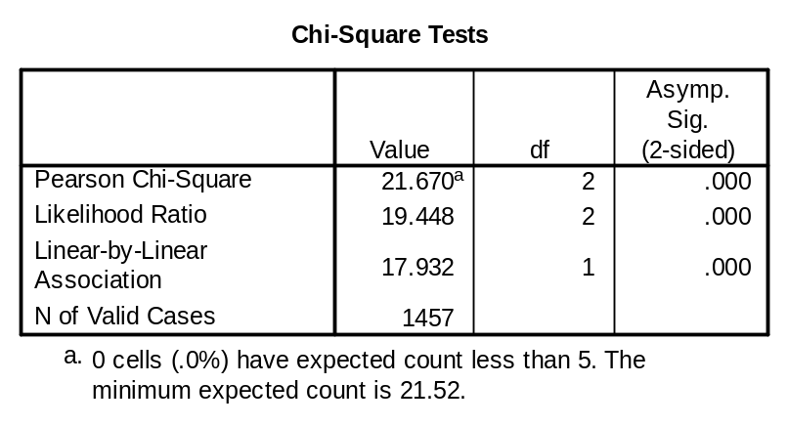

Thus white people are significantly happier than black people in the 1991 U.S. General Social Survey are.

Happiness and region,

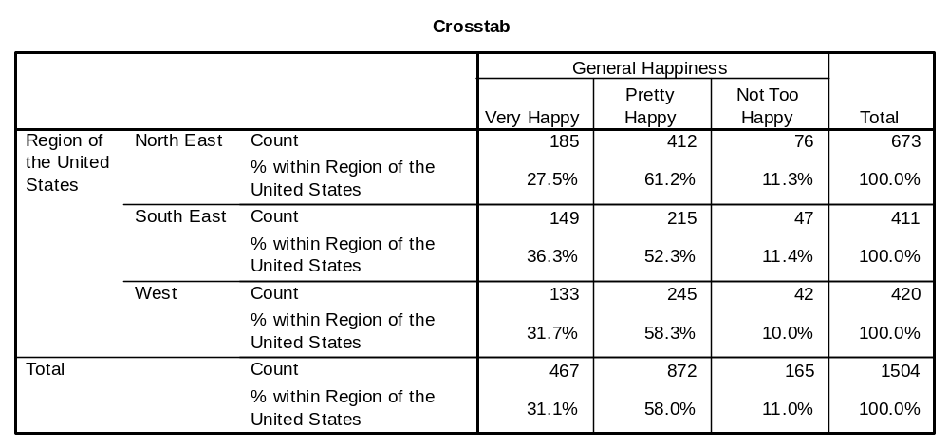
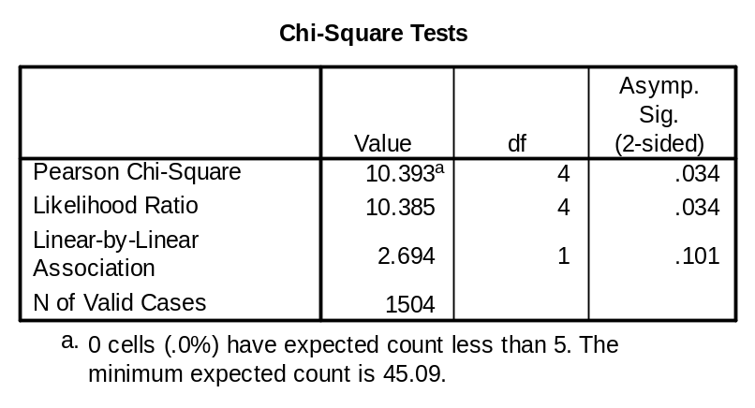

There are significantly fewer people in the North East who are described as “very happy”.

To put this into a binary regression model the variable happiness needs to be recoded. Currently happiness is scored 1 or 2 for very and pretty happy respectively and 3 for unhappy - this can be changed into a binomial response of 0 if unhappy and 1 if happy and the probability of being happy computed using logit (logistic) regression.

Classification Table for HSCORE
The Cut Value is .50
 | Predicted Happiness
Observed  Happiness | No | Yes | Per cent Correct
No | 0 | 156 | 0%
Yes | 0 | 1301 | 100%
 | Overall correct |  | 89.29%

Variables in the Equation:
Variable | B | S.E. | Wald | df | Sig | R | Exp(B)
RACE(1) | -0.8201 | 0.2039 | 16.1715 | 1 | 0.0001 | -0.1195 | 0.4404
SEX(1) | -0.4439 | 0.1816 | 5.9735 | 1 | 0.0145 | -0.0633 | 0.6415
Constant | 2.5471 | 0.1535 | 275.2307 | 1 | 0.0000
RACE(1) = black
SEX(1) = female

----------------- Model if Term Removed ------------------
Term Log Significance
Removed Likelihood -2 Log LR df of Log LR

RACE -492.186 14.628 1 .0001
SEX -487.969 6.194 1 .0128

--------------- Variables not in the Equation -----------------
Residual Chi Square 0.615 with 2 df Sig = 0.7354

Variable Score df Sig R
REGION .6146 2 .7354 .0000
REGION(1) .0466 1 .8292 .0000 – South East
REGION(2) .3909 1 .5318 .0000 - West

(The effect of living in the South East or in the West is compared here to the North East).

Although the model has not done a good job in identifying unhappy people, the suggestion is that the probability of someone being happy is greater if they are male and white. Region of residence does not appear to have a significant effect.

Predicted Probability is of Membership for No problem
The Cut Value is .50
Symbols: Y - Yes a problem
N - No problem
Each Symbol Represents 100 Cases.
13.4 References

Bryman, A. and Crammer, D., 2004, Quantitative Data Analysis with SPSS 12 and 13: A Guide for Social Scientists, London, Routledge.

Ott, R. L., 1988, An introduction to Statistical Methods and Data Analysis, Belmont Ca, Duxbury.

Sharma, S., 1996, Applied Multivariate Techniques. Chichester, Wiley.

13.5 Exercises

- In 1996 John Bongaarts and Susan Watkins advocated that the fertility of a nation is related to its “Human Development Index”, which is a composite measure of the log of GDP per capita, female literacy and female life expectancy. From the data in World.Sav construct the HDI using factor analysis and determine a regression model for fertility. Identify any outliers and consider their effect.

2. The file Contract.sav contains data on the degree to which an outsourcing arrangement was successful and how the company scored on a rating questionnaire prior to establishing the relationship. Use factor analysis to construct some latent variables and develop a model to allow the success rating to be estimated from the questionnaire scores.
The questionnaire was: Rate the potential outsourcer on the scales
shown in the following table.

Criteria | Very Weak Very Strong  1 2 3 4 5
Technical Capability
Ability to manage Projects
Collaborator’s track record
Strength of Communication Links
Compatibility of Operating Cultures
Compatibility of Strategic Aims
Collaborator’s Development Speed
Collaborators Development Costs
Business Strength of Collaborator
Financial Resources of Collaborator
Security
Strategic Position

- The file fin.sav contains data on whether or not a company was successful. The variables are company size and financial performance (fp). Construct a logistic model to classify the firms as successful or unsuccessful.

- In 1846 a Wagon Train left Springfield, Illinois bound for California. Unfortunately while crossing a mountain range their path was blocked by snow and they had to spend the winter in the mountains. Many died but some survived and this became known as the Donnor party. The ages and gender, (female = 1) of the party were known and these were used to compute the probabilities of some one surviving using logistic regression. The data is in the file Donner.Sav

- Describe this output.
- Compute the probability of a female aged 45 surviving?
- Suggest two other variables that could have been used in the analysis, assuming that the information would have been available.
5. The file S&L.sav is a data set of 35 U.S. savings institutions. The beta and sigma variables are used to estimate the rate of return. Conduct a regression model examining for influential observations and produce a good model to estimate the rate of return.

